Applicative part

- Experimental analysis:
  - Datasets used

Experiments will be performed on both public and real datasets. First, two publicly available datasets are targeted, CCSN and Ground-based Cloud Dataset (GCD), which differ in size, number of cloud classes and complexity. The CCSN dataset, previously used in the clouds classification literature, consists of 2543 images having a resolution of 256×256 pixels, divided into 11 classes [20]. The GCD dataset includes 19000 images having a resolution of 512×512 pixels captured in China with a total of 7 classes and the split of training and testing instances is 10000 and 9000 images respectively. Besides the publicly available datasets, we aim to use RS data such as satellite images provided by European Organisation for the Exploitation of Meteorological Satellites (EUMETSAT) and radar data provided by the Romanian ANM. We will use satellite imagery from the Meteosat-11 satellite of EUMETSAT, a geostationary satellite orbiting Earth at 35.786 km above the Equator, providing a continuous stream of images (one image every 15 minutes) of the entire Earth disc, to monitor the weather over Europe and Africa. In addition to the satellite images, radar data collected by a Doppler single-polarisation radar located in central Romania is targeted. In a full volume scan, completed every 6 minutes, the radar outputs many different products related to the location, intensity and the movement of precipitating clouds and their associated meteorological phenomena. The most important radar products are the base Reflectivity (R) product and the base Velocity (V) product. The radars collect these base products at 9 elevation angles, gathering 9 sets of velocity or reflectivity data at each time step.

  - Evaluation

For training our models, we aim to use best ML practices such as: (1) choosing an appropriate loss function; (2) choosing or refining optimizers (AdamW, Learning Rate Schedulers, Gradient Clipping); (3) employing learning rate schedules to stabilise the training; (4) applying regularisation techniques (weight decay or dropout) to prevent overfitting and improving generalisation; (5) hyperparameters optimization.
For assessing the performance of our proposed models, a k-fold cross-validation testing methodology will be applied and confidence intervals for the mean performance will be provided. Given a testing set, various metrics used in the classification literature for performance evaluation will be computed: accuracy, precision, sensitivity (also known as recall or probability of detection), specificity, F1 score, Area under the Precision-Recall curve (AUPRC) and Area under the ROC curve (AUC). All these performance metrics are computed based on the generalised confusion matrix obtained for the multiclass classification problem. Besides the aforementioned evaluation measures, we aim to employ metrics from the weather forecasting literature such as the class-based critical success index (CSIC=TPCTPC + FPC + FNC) and false alarm rate _{(FARC}=FPCTPC + FPC) aggregated as averages. We note that for image generation measures such as Fréchet Inception Distance (FID), Inception Score (IS), Perceptual Similarity Metrics (e.g., LPIPS, SSIM) will be used.

  - Mathematical model
    - Proposed architectures.

Using either one or both the ViT and the Diffusion Classifier represents a novel perspective that is currently explored within the research community, without being employed for cloud image classification and related tasks yet. The hybridization involves designing multiple pipeline ideas for combining both mechanisms. Below we present three of our proposals for hybridisation, with an emphasis on the first two. Our aim is to implement two of the proposed architectures in order to comparatively assess their performance.

      - (1) Conditional Diffusion via ViT Features.

With this approach, the ViT would be used to extract high-level semantic features from the input images, which would then be used as conditioning information for the Diffusion model throughout the denoising process. Additionally, the Diffusion model can be used for both classification and generation of cloud images. At each timestep, while progressively denoising the random noise back into an image within a neural network-based pipeline like U-Net, the ViT provided features are used as a conditioning value, by performing concatenation, feature modulation with the existing processed information, or by using them to control noise levels. Training of such an architecture can be split into two stages, first one only involving the pre-training of the ViT for image classification tasks. Afterwards, a Joint Training of both models could be performed, potentially giving better results by having a pre-trained ViT. This pipeline can ultimately be used for both classification and generation, and therefore the loss function could be computed to correct the models for both scenarios. Figure 3 illustrates a high-level design of this architecture.

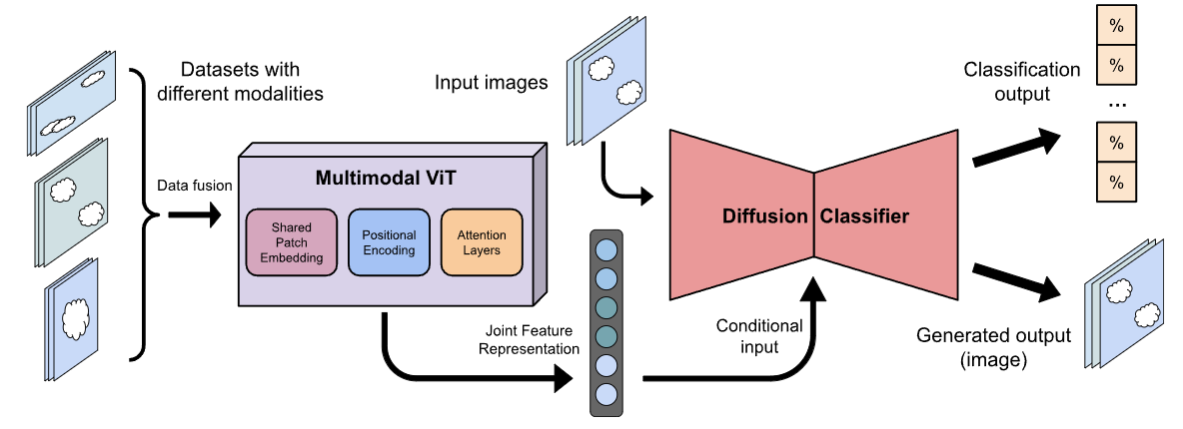

Figure 1. An overview of the proposed Conditional DiT Classifier architecture

      - (2) Diffusion Transformer Hybrid.

For this architecture design, the ViT model is essentially integrated within the Diffusion Classifier. It is responsible for providing the next step’s prediction of noisy image representations at each timestep of the reverse diffusion process. The ViT tries to minimise the noise by applying self-attention. Consequently, it optimises its attention weights and feature extraction, ensuring that global context and semantic structure of the image are always preserved. Nevertheless, the overall noise schedule is still managed by the Diffusion model. This hybrid model uses loss functions for both denoising and classification, such as Denoising Loss (for both models), Self-Attention Loss (for the ViT), and Cross-Entropy Loss for classification. The total loss function would be a combination of all these losses, where the lambdas represent the importance of the corresponding loss:
      - (3) Parallel Processing with Cross-Attention.

Another possible design is that of the two models performing operations in parallel but interacting through a cross-attention mechanism. For instance, the ViT receives an image and captures global structure from it, while the Diffusion Classifier separately performs denoising steps progressively. Afterwards, cross-attention is used to help one model attend to the features of the other model and vice-versa. This idea would match either for classification of images, where the final result can be computed by fusing the features from both models, or for generation, such that the diffusion model’s generated image can adhere to the extracted features of the ViT, refining and improving image details.

    - Common aspects
      - Vision Transformer

From a technical perspective, transformers are a complex type of Deep Neural Networks (DNN) that rely on the mechanism of attention [8]. They proved to perform better than other competitive alternatives such as Recurrent Neural Networks (RNNs) or CNNs in terms of computation time and efficiency. For an image processing task such as classification of clouds, this is guaranteed by its ability to capture both local and global relationships between patches, which constitute the original image. Figure 1 illustrates the architecture of a ViT model. The operation of a ViT can be divided into several crucial steps [9]. Firstly, the input image is divided into equal flattened patches, which are then projected into Patch Embeddings. Afterwards, a Positional Embedding is added, which is calculated using a specific scheme, e.g. sinusoidal encoding due to the smooth variation of sine and cosine functions and ability to distinguish position differences. Furthermore, the embeddings are fed into an encoder, where Multi-Head Self-Attention is employed. This performs multiple concatenated partial basic Self-Attention operations by involving three essential vectors, i.e., the patch-specific Queries (Q), attended patch-specific Keys (K) and the actual information-holding Values (V). The operations can be formally represented as:

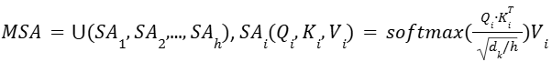,

where d_{k} is the embedding dimension, h represents the number of parts the matrices were divided into (each one having d_{k}/h dimensionality), and i is a specific part [9]. Finally, embeddings are processed through a Feed-Forward Network (FFN) and then a prepended globally representative classification token ([CLS] token) is extracted as the final output.

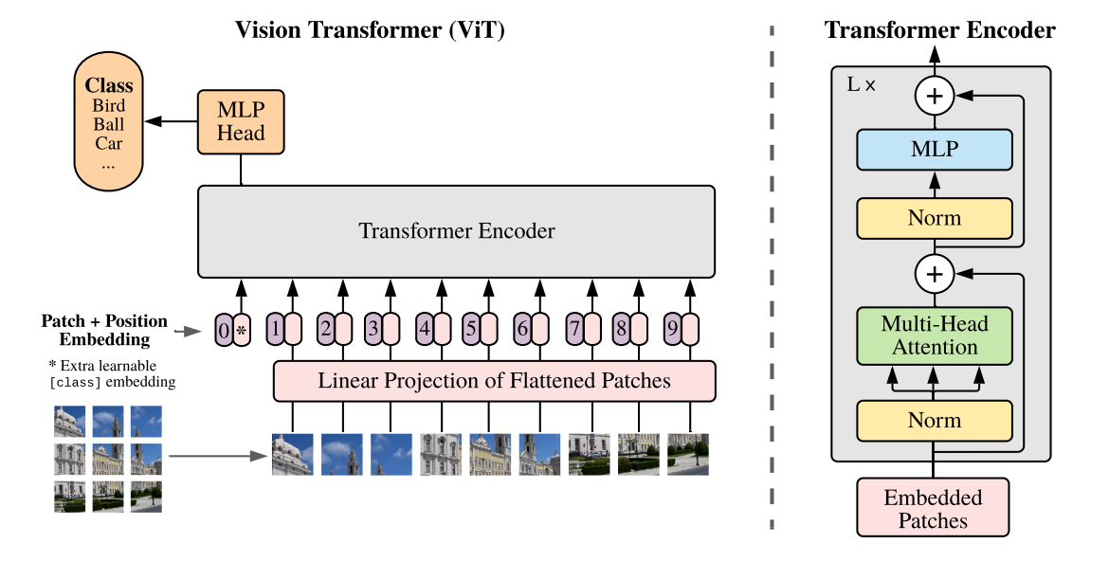

Figure 2. Architecture of the ViT model [9]

      - Diffusion classifier
Diffusion Probabilistic Models [11] fundamentally differ from other existing approaches, e.g. Variational Autoencoders (VAEs) or Generative Adversarial Networks (GANs). In essence, they effectively try to learn a bijection between original domain and pure noise space by incrementally performing noising and de-noising transformations to a given image, which are also called forward and reverse diffusion.
Firstly, the forward diffusion performs multiple slight noising operations to the original image, to altering each pixel to certain degree, which is dictated by the scheduler, which depends on timestep t and can be linear or cosine-based. The operation can be represented by the formula:
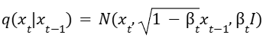,
where q is the forward process function, $x_{t-1}$ and $x_{t}$ are the input and the output at step t respectively, and $Ν$ represents the normal distribution. Afterwards, the denoising process is performed through multiple timesteps instead of directly transforming pure noise into the real expected image, which is the case of GANs. For each step, the noise would be passed through an architecture that outputs the most likely noise which could be subtracted from the input to receive the best estimation of the real image. The reverse diffusion pipeline is typically a neural network, such as U-NET which makes use of self-attention mechanisms. The specific formula [10] of the reverse process function p is:
,
Where (x_{t}, t) represents the model’s output, 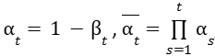, and $μ_{θ}$ and $Σ_{θ}$ represent the mean and variance respectively.
The Diffusion Classifier [10] relies on the same core principles, but instead of giving a generated image as output, it tries to predict the class y of the input image. It tries to minimise a certain loss function, such as cross-entropy, while also performing the same forward and reverse diffusions. This evaluation occurs at various noise levels by receiving a conditional class index within each down sampling and up sampling block while processing the noisy image xt at timestep t: p(y|x_{t}). This repeated process makes the classifier robust to noisy images. Core principles of such a classifier are shown in Figure 2. In essence, the underlying formula for probability of having class ci from image x relies on the Bayes formula:
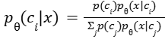

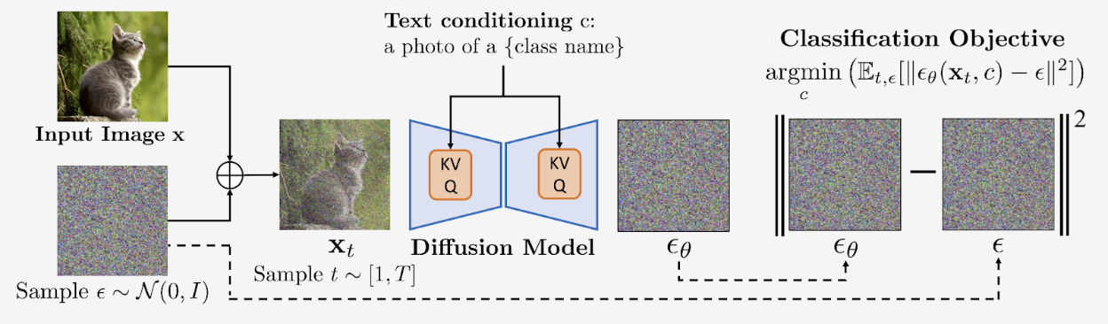

Figure 3. A simplified overview of the Diffusion Classifier model

      - Multimodal data-fusion
Multimodal Data Fusion [19] combines different data streams with various characteristics to produce more helpful information. It integrates data of diverse dimensionality, resolution, and type (such as RS data) to achieve specific goals in multiple applications. Deep learning (DL) has been successfully applied to multimodal remote sensing data fusion, providing significant improvement compared with traditional methods. Li et al. [15] recently reviewed DL-based multimodal remote sensing data fusion methods. Remote sensing modalities include Panchromatic (Pan), Multispectral (MS), Hyperspectral (HS), Light detection and ranging (LiDAR), SAR, infrared, nighttime light, and satellite video data. The paper divided existing methods into two main groups: homogeneous fusion (e.g., pan sharpening, spatiotemporal fusion) and heterogeneous fusion (e.g., remote sensing geospatial data). According to Li et al. [15], commonly used supervised models for DL-based homogeneous and heterogeneous fusion are Autoencoders (AEs), CNNs, GANs and ViT-based architectures.

- Case study on Initial Data: Conducting Experiments on a Smaller Dataset to Illustrate Methodology and Potential of the Approach
We aim to illustrate the methodology and potential of our approach for classifying cloud images using a smaller dataset. This study is valuable for articles and reports, providing concrete examples that describe the original approach. We will present the creation/collection of data, implementation of the relevant code to run experiments on this initial dataset, and validation/collection of data that demonstrates the efficiency of the proposed approach (metrics, empirical evidence, explanations/interpretations from experts).

  - Data Creation/Collection
For this case study, we utilized a modified version of a smaller dataset named "mini-GCD", which contains real cloud images classified into two categories: "clearsky" and "cloudy." The dataset is divided into two subdirectories: train, and test.
  - Implementation of the Code
The relevant code for our approach was implemented in Python, leveraging libraries such as torch, torchvision, and segmentation_models_pytorch. As a baseline implementation, we employed the principal component of a diffusion model, more specifically a pre-trained U-Net model on ImageNet as a feature extractor, to which we appended a classifier to perform image classification.
  - Experiments and Results
We trained the model on the training dataset and evaluated its performance on the validation set. The results obtained during training are presented below:
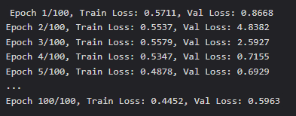

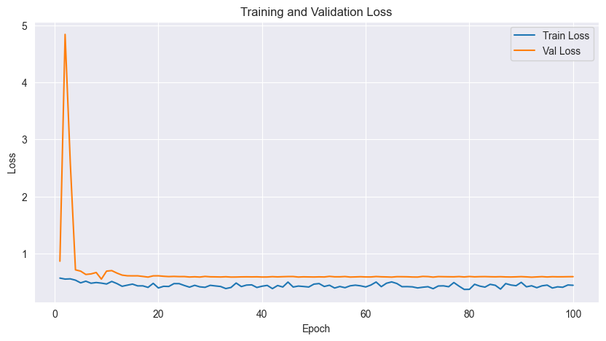

Figure 4. Evolution of training and validation losses during the fine-tuning period of the initial U-Net based classifier

  - Performance Evaluation
To evaluate the model's performance, we selected a subset of images from the test set and calculated various performance metrics. A confusion matrix displaying the evaluation results is presented below. The results indicate that the model achieves a decent performance in classifying cloud images, with an accuracy of 75%. The precision, recall, and F1 score are equal (and have the same value as the accuracy), suggesting a balance between accuracy and sensitivity. However, there is still room for improvement, particularly in handling underrepresented classes.

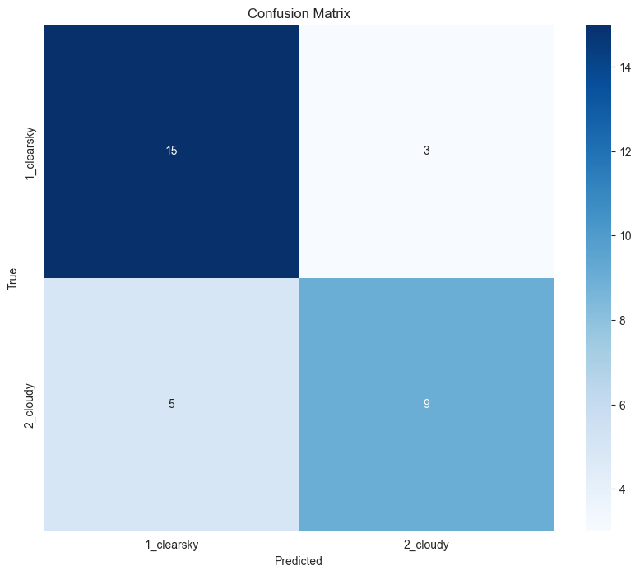

Figure 5. Confusion matrix of result provided by the selected dataset sample.

  - Discussion on sample data
We selected a random sample of 2 batches of 8 images each (i.e., a total of 16 images) to observe the behavior of the model. This subset of images was chosen to provide a comprehensive understanding of how the model processes and classifies cloud images. Each image in the sample underwent a series of transformations and computations as it passed through the various layers of the U-Net architecture.

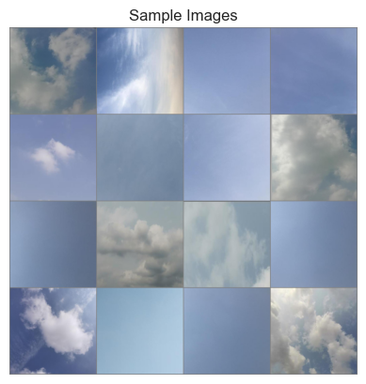

Figure 6. Illustration of the sampled images.

Initially, the images were preprocessed using standard augmentation techniques such as resizing, normalization, and data augmentation to enhance the model's generalization capabilities. These preprocessed images were then fed into the U-Net model, which is composed of an encoder and a decoder path. The encoder path, consisting of a series of convolutional layers followed by max-pooling operations, progressively downsampled the images to extract high-level features. Simultaneously, the decoder path, comprising upsampling layers and skip connections, reconstructed the spatial dimensions of the images while incorporating the high-level features from the encoder. Throughout this process, the model applied mathematical formulas such as convolutions, activations, and pooling operations to transform the input data. For instance, the convolutional operation can be mathematically represented as:
$\text{Conv}\left(I,K\right)=\sum_{m}{\sum_{n}{I\left(x-m,y-n\right)}}⋅K\left(m,n\right)$,
where I is the input image, K is the convolutional kernel, and (x,y) are the pixel coordinates. The activation functions, such as ReLU, introduced non-linearity, enabling the model to learn complex patterns. The ReLU activation function is defined as:
$$\text{ReLU}\left(x\right)=\max\left(0,x\right)$$
The pooling operations reduced the spatial dimensions, focusing on the most salient features. Max-pooling, for example, can be described as:
$\text{MaxPool}\left(I,s\right)=\max_{i,j∈s}{I}\left(i,j\right)$,
where s is the pooling window size.
The intermediate feature maps generated by the U-Net model were visualized to provide insights into the feature extraction process. These feature maps highlighted the regions of the images that the model deemed significant for classification.

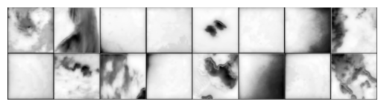

Figure 7. Corresponding feature maps of the sampled images.

Finally, the extracted features were passed through a classifier, which consisted of an adaptive average pooling layer, a batch normalization layer, a dropout layer, and a fully connected layer. This classifier produced the final predictions, which were compared against the ground truth labels to evaluate the model's performance. The visualization of the initial images, their corresponding feature maps, and the final predicted versus actual labels offered a holistic view of the model's decision-making process. This approach not only aided in understanding the model's behavior but also provided empirical evidence of its effectiveness in classifying cloud images.

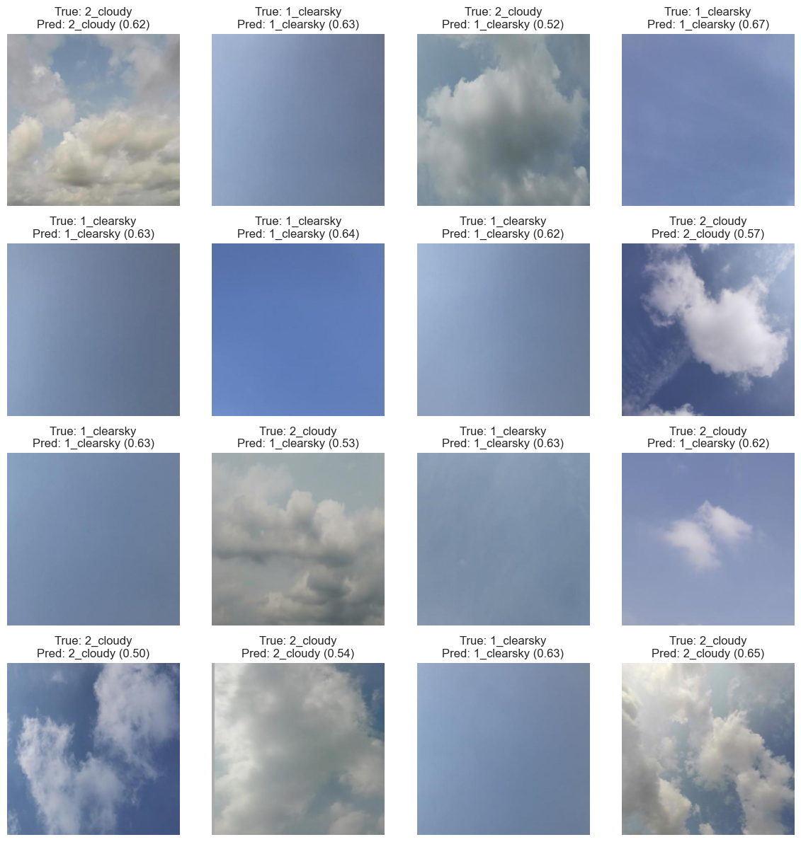

Figure 8. Corresponding feature maps of the sampled images.

  - Conclusions
This case study has effectively illustrated the methodology and potential of our approach for classifying cloud images. The results are promising, but there is still scope for enhancement. In the future, we will explore additional techniques to improve performance, such as integration with a Vision Transformer, employing generative data augmentation, regularization, and hyperparameter tuning.

- Related work on clouds classification from images

  - Many research papers have approached the subject of weather prediction and classification of clouds using very diverse technical means, and in recent years there have been some novel ideas that bring very good results in specific contexts. The used learning mechanisms range from supervised to unsupervised, and the architectures consist of multiple structures with different purposes that rely on each other and provide the results overall. We are further reviewing several recent supervised and self-supervised related work.
  - Luo et al. [1] introduced a YOLOv8 based pre-trained Deep Neural Network (DNN), which outputs a bounding box and the most probable class an image belongs to. Experiments conducted on 4000 images captured by an observation instrument at Yangbajing Observatory Station in Tibet provided 100% accuracy overall during the training stage but having lower results for the highly complex cumulus clouds. The authors observed local cloud fluctuations based on the seasons of the year or diurnal parts. Yousaf et al. [2] addressed the problem of interclass similarities and class imbalance problems found in the used datasets. Data used for the training stage is taken from the Large-Scale Cloud Images Dataset for Meteorology Research, which is claimed to be the first publicly available database and one of the most challenging ones, due to the aforementioned problems. It is made of over 100,000 satellite images captured by the Himawari-8 satellite and divided into 11 classes [20]. A Convolutional Neural Network (CNN) and Residual Network (ResNet)-based model, proposed by He et al. [7], was used. Data augmentation was also used for balancing the size of training classes, by applying simple colour and geometric transformations to some of the existing images, e.g. image flips and rotations and brightness and scale variations. The model was trained over the span of two snapshots of 100 epochs each, resulting in an accuracy of 97.25%.
  - Togaçar et al. [3] proposed a ShuffleNet-based model, which is a lightweight architecture with reduced number of trainable parameters, designed and optimized for mobile devices as well. Images used belong to Cirrus Cumulus Stratus Nimbus (CCSN) and SWIMCAT-Ext databases. Instances belong to eleven and six classes respectively, and suffer from class imbalance. Therefore, Super-Resolution (SR) and Semantic Segmentation (SS) are performed, using a Residual Dense Network and an Xception-based model. The best accuracy was reached when using Linear Discriminant Analysis, raising the value from 96.45% to 98.56%. Dev et al. [4] proposed a texton-based texture classification model, which includes K-means clustering on computed feature filters, which results in a texton dictionary. S-filters (essentially rotation-invariant Gabor-like filters) are used in the convolution layers to combine colour and texture information. Singapore Whole-sky Imaging CATegories is used as a data source containing 784 patches belonging to 5 categories, captured around Singapore over the period of January 2013 to May 2014. After multiple evaluations, S-filters and hyperparameter tunings were tested, the model approached perfect classification accuracy, with a small exception for the veil-type clouds. Vasylieva et al. [5] described a CNN to classify images captured by the NOAA-20 Visible Infrared Imaging Radiometer Suite satellite into 4 classes. Presented layers are convolution, max-pooling, followed by softmax activation. After a 20-epoch training session, accuracy resulted in 95% and 85% for training and validation data respectively, even though the model tends to make slight confusions between cirrus and stratocumulus cloud classes. Geiss et al. [6] proposed a special type of self-supervised learning which makes use of a Siamese Neural Network (SNN). The two datasets which were used are Moderate Resolution Imaging Spectroradiometer, a multispectral imager that orbits aboard NASA’s EOS Terra satellite, and Advanced Baseline Imager, an imager aboard the GOES-17 satellite. A total of 64 340 instances for MODIS and 91 077 for ABI are used for training, while testing data is used from Aqua and Terra MODIS data sources. The SNN is based on a ResNet-style encoder CNN and receives two batches of input data, for which simple data augmentations were also applied. The testing stage provided an accuracy over 80%.

  - Comparison with proposed architectures

Our proposed approaches—a diffusion/U-Net based cloud classification model and a Vision Transformer (ViT) classifier—offer a novel perspective on this challenging task. These architectures have been meticulously designed to address the intricacies of cloud classification, leveraging advanced deep learning techniques to achieve superior performance.

Our diffusion/U-Net based model, while not achieving the highest accuracy, demonstrates significant potential. The U-Net architecture, known for its effectiveness in segmentation tasks, provides a robust framework for feature extraction and classification. The U-Net model consists of an encoder-decoder structure with skip connections, which allows it to capture both high-level and low-level features effectively. This architecture is particularly well-suited for tasks that require detailed spatial information, such as cloud classification. Despite its current performance, the U-Net model has the potential to surpass state-of-the-art (SOTA) methods with further refinement and optimization. The integration of diffusion techniques enhances the model's ability to capture complex patterns and nuances in cloud images, making it a promising candidate for future advancements in this field.

The Vision Transformer (ViT) classifier, on the other hand, has shown remarkable performance, achieving near-perfect accuracy and excellent results across various metrics. The ViT architecture, with its transformer-based approach, excels in capturing global context and long-range dependencies in the data. This makes it particularly well-suited for cloud classification tasks, where understanding the broader spatial relationships within images is crucial. The ViT classifier's outstanding performance underscores its effectiveness and positions it as a leading contender among existing methods. The ViT model leverages self-attention mechanisms to weigh the importance of different parts of the image, allowing it to focus on the most relevant features for classification. This architectural advantage sets the ViT classifier apart from traditional convolutional neural networks (CNNs) and other models used in related work. Overall, our proposed architectures, especially the ViT classifier, demonstrate the potential to set new benchmarks in the field of cloud classification.

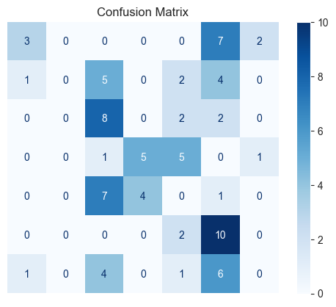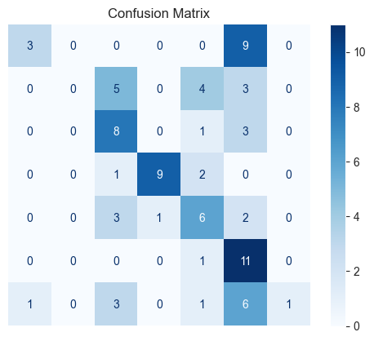

Figure 9. Preliminary results of second ViT-based architecture with and without additional trainings technqiues applied.

Bibliography:
- Luo, J.; Pan, Y.; et al. Innovative Cloud Quantification: Deep Learning Classification and Finite-Sector Clustering for Ground-Based All-Sky Imaging. Atmospheric Measurement Techniques 2024, 17, 3765–3781
- Yousaf, R.; Rehman, H.Z.U.; Khan, K.; Khan, Z.H.; Fazil, A.; Mahmood, Z.; Qaisar, S.M.; Siddiqui, A.J. Satellite Imagery-Based Cloud Classification Using Deep Learning. Remote Sens. 2023, 15, 5597.
- Togaçar, M.; Ergen, B. Classification of cloud images by using super resolution, semantic segmentation approaches and binary sailfish optimization method with deep learning model Computers and Electronics in Agriculture, Vol. 193, Article id 106724, 2022
- S. Dev, Y. H. Lee and S. Winkler, Categorization of cloud image patches using an improved texton-based approach, 2015 IEEE ICIP, 2015, pp. 422-426
- A. Vasylieva, R. Melnyk, Classification of cloud types on satellite images using deep learning, Manazerska Informatica, Vol. 3, 2022, pp. 1-13
- Geiss, A., M. W. Christensen, A. C. Varble, T. Yuan, and H. Song, 2024: Self-Supervised Cloud Classification. Artif. Intell. Earth Syst., 3, e230036
- Kaiming He, Xiangyu Zhang, Shaoqing Ren, Jian Sun: Deep Residual Learning for Image Recognition. IEEE / CVF Computer Vision and Pattern Recognition Conference (CVPR) 2016: 770-778
- Vaswani, A.; Shazeer, N.; et al. Attention Is All You Need 2017, NIPS 2017:5998-6008
- Dosovitskiy, A.; Beyer, L.; et al. An Image is Worth 16x16 Words: Transformers for Image Recognition at Scale, ICLR 2021:1-22
- Li, A. C.; Prabhudesai, M. et al. Your Diffusion Model is Secretly a Zero-Shot Classifier, ICCV 2023: 2206-2217
- J. Ho, A. Jain, P. Abbeel, Denoising Diffusion Probabilistic Models, NeurIPS 2020, pp. 6840-6851
- W. Ye, Y. Li, and D.-L. Zhang, Generation of Extreme Precipitation over the Southeastern Tibetan Plateau Associated with TC Rashmi (2008), Weather and Forecasting, vol. 37, no. 12, pp. 2223 – 2238, 2022.
- J. L. Bytheway, M. Hughes, R. Cifelli, K. Mahoney, and J. M. English, Demonstrating a Probabilistic Quantitative Precipitation Estimate for Evaluating Precipitation Forecasts in Complex Terrain, Weather and Forecasting, vol. 37, no. 1, pp. 45 – 64, 2022
- Jiaxin Li, Danfeng Hong, et al., Deep learning in multimodal remote sensing data fusion: A comprehensive review, International Journal of Applied Earth Observation and Geoinformation, Volume 112, 2022, 102926
- R. Bokade, A. Navato et al., A cross-disciplinary comparison of multimodal data fusion approaches and applications: Accelerating learning through trans-disciplinary information sharing, Expert Systems with Applications, Volume 165, 2021, 113885

